**Assignment No: 1**

**1. Write a typescript program which contains one function named as Maximum. That function accepts three parameters and it should returns largest value from three input parameters.**

**Input: 23 89 6**

**Program:**

function Maximum(Value1:number,Value2:number,Value3:number):number

{

    var temp:number=0;

     if(Value1>Value2 && Value1>Value3)

     {

        temp=Value1

     }

     else if(Value2>Value1 && Value2>Value3)

     {

        temp=Value2

     }

     else

     {

        temp=Value3

     }

    return temp

}

var No1:number=23;

var No2:number=89;

var No3:number=6;

var MaxNo:number=0;

MaxNo=Maximum(No1,No2,No3);

console.log("Maximum no is : "+MaxNo);

**Output:** 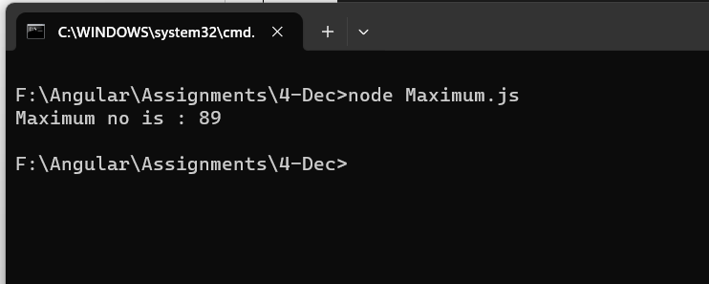

**2. Write a typescript program which contains one function named as Area. That function should calculate area of circle. Accept value of radius from user and return its area. Default value of PI should be 3.14 if it is not provided by the caller.**

**Input: 5**

**Program:**

function AreaofCircle(R:number):number

{

    var Result:number=0;

    var Pi:number=3.14;

    Result=Pi*(R*R);

    return Result;

}

var Area:number=0;

var Radius:number=5;

Area=AreaofCircle(Radius);

console.log("Area of circle is "+Area);

**Output:**

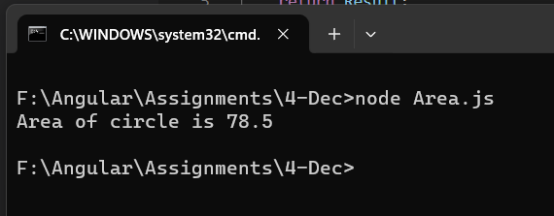

**3. Write a typescript program which contains one function named as DisplayFactors. That function should accept one number and display factors of that number.**

**Input: 20**

**Program:**

function Factors(Value1:number):void

{

    var temp:number=0;

    for(var j:number=0;j<Value1;j++)

    {

        if(Value1%j==0)

        {

            console.log(j);

        }

    }

    }

var No1:number=20;

Factors(No1);

**Output:**

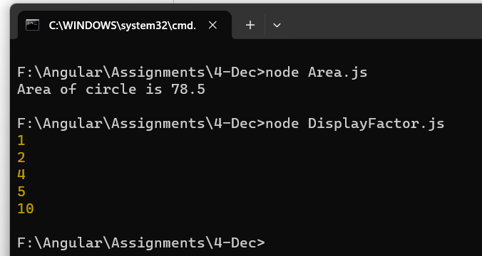

**4. Write a typescript program which contains one function named as ChkPrime. That function should accept one number and it should return true if the given number is prime and otherwise return false.**

**Input: 11**

**Program:**

function PrimeNo(No1:number): boolean

{

if(No1%1==0 && No1%No1==0 && No1%2!=0)

{

    return true;

}

else

{

    return false;

}

}

 var Value1:number=11;

 var Result:boolean;

 Result=PrimeNo(Value1);

 if(Result==true)

 {

    console.log("Given number is Prime Number");

 }

 else

 {

    console.log("Given number is Not Prime number");

 }

**Output:**

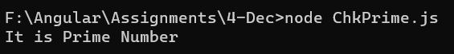

**5. Write a typescript program which contains one function named as Fibonacci. That function accept one number from user and print Fibonacci series till that number.**

**Input: 21**

**Program:**

function Fibonacci(No1) {

    var Value1 = 0;

    var Value2 = 1;

    var Value3 = 0;

    for (var i = 1; i <= No1; i++) {

        if (Value1 <= No1) {

            console.log(Value1);

            Value3 = Value1 + Value2;

            Value1 = Value2;

            Value2 = Value3;

        }

        else {

            break;

        }

    }

}

var Num = 21;

Fibonacci(Num);

**Output:**

